

Model Development Phase Template

Name | Nilofar Rafik Shaikh
Skillwallet ID | SWUID20260283092
Project Title | Uncovering the Hidden Treasures of the  Mushroom Kingdom: A Classification Analysis
Maximum Marks | 10 Marks

Initial Model Training Code, Model Validation and Evaluation Report
Initial Model Training Code

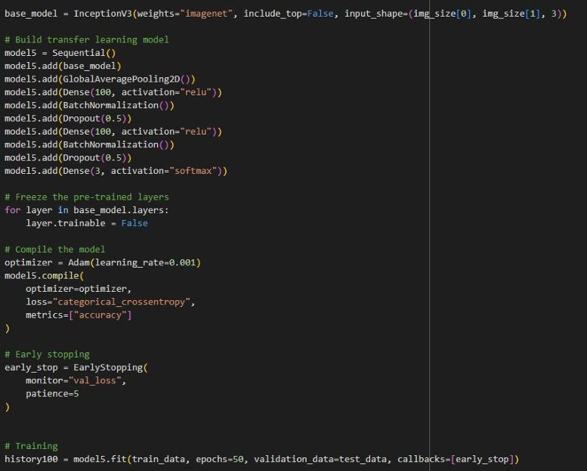


Model Validation and Evaluation Report

Model | Summary | Training and Validation Performance  Metrics
Model 1  (InceptionV3 +  Custom Layers) | Layer Summary:  - InceptionV3 base model  - GlobalAveragePooling2D  - Dense(100, relu)  - BatchNormalization  - Dropout(0.5)  - Dense(3, softmax)  Total Parameters:  2,311,305  Trainable Parameters:  2,304,505  Non-trainable  Parameters: 6,800 | Training Accuracy: 83.42%  Validation Accuracy: 88.36%  Training converged well with slight overfitting mitigated by dropout and batch normalization.

